**Project: Case Study (Part - II)**

*Plots and Explanation*

by

**(Piyush Pravin)**

**Question 1:**

Your Friend has developed the Product and he wants to establish the product startup and he is searching for a perfect location where getting the investment has a high chance. But due to its financial restriction, he can choose only between three locations -  Bangalore, Mumbai, and NCR. As a friend, you want to help your friend deciding the location. NCR include Gurgaon, Noida and New Delhi. Find the location where the most number of funding is done. That means, find the location where startups has received funding maximum number of times. Plot the bar graph between location and number of funding. Take city name "Delhi" as "New Delhi". Check the case-sensitiveness of cities also. That means, at some place instead of "Bangalore", "bangalore" is given. Take city name as "Bangalore". For few startups multiple locations are given, one Indian and one Foreign. Consider the startup if any one of the city lies in given locations.

**Explanation:**

My friend is searching for the perfect location to start the product startup, but due to financial restriction, he can start startup only in Bangalore, Mumbai, NCR (Gurgaon, Noida, New Delhi).

* First of all I have dropped the NaN values. Then as per given in the question corrected the misspelled city names.
* I have calculated the number of funding for each of these cities and drawn a Bar Graph between city and number of funding.
* Then I have drawn a Bar graph between location and number of funding by combining the count of New Delhi, Noida and Gurgaon.
* From the graph it clear that Bangalore is the city which received the maximum number of funding then Mumbai then New Delhi, then Gurgaon and Noida.
* So for start-up funding, Bangalore is the best city and Location wise NCR is best suitable for friend.

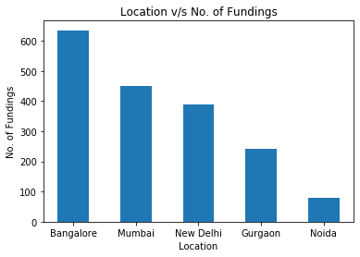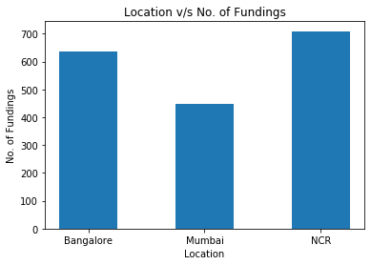**The location where the most number of funding is done is : NCR 709**

**Question 2:**

Even after trying for so many times, your friend’s startup could not find the investment. So you decided to take this matter in your hand and try to find the list of investors who probably can invest in your friend’s startup. Your list will increase the chance of your friend startup getting some initial investment by contacting these investors. Find the top 5 investors who have invested maximum number of times (consider repeat investments in one company also). In a startup, multiple investors might have invested. So consider each investor for that startup. Ignore undisclosed investors.

**Explanation:**

Even after trying many times my friend’s startup could not get the investment. So I tried to find the list of investors that can invest in my friend’s startup. Then from that list, I found top 5 investors who have invested maximum number of times and drawn a pie graph for number of invest and a Bar Graph between investor and number of investments.

* So these are the five investors who have invested in startup maximum number of times. But many times they have invested in repeated startup.
* While finding the top 5 investors I have ignored the undisclosed startup.
* So me and my friend would try to contact with these top 5 investors.
* From graph and pie chart it clear that the top 5 investors are

Investor | No_of_time_invest

-------------------------------------------

Sequoia Capital | 64

Accel Partners | 53

Kalaari Capital | 44

SAIF Partners | 41

Indian Angel Network | 40

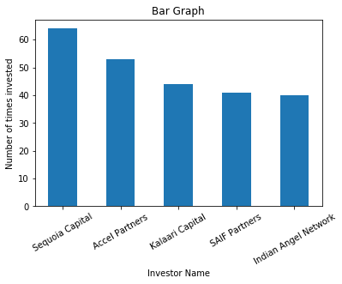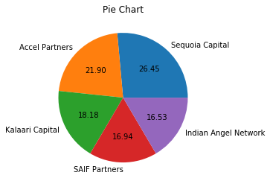

**Question 3:**

After re-analysing the dataset you found out that some investors have invested in the same startup at different number of funding rounds. So before finalising the previous list, you want to improvise it by finding the top 5 investors who have invested in different number of startups. This list will be more helpful than your previous list in finding the investment for your friend startup. Find the top 5 investors who have invested maximum number of times in different companies. That means, if one investor has invested multiple times in one startup, count one for that company. There are many errors in startup names. Ignore correcting all, just handle the important ones - Ola, Flipkart, Oyo and Paytm.

**Explanation:**

After putting so much efforts my friend still could not get the fund, because many investors were investing in same startup. So I found the list of those investor who have invested in different startups, it would increase the chances to get the fund. So I have found the top 5 investor who invest in different startup.

Drawn a Bar graph between Investor and number of times he invest. And pie graph for the number of investments.

* In pie graph these are the five investors who invested in different startups maximum number of times.
* So these five investor’s information is better than the previous five investors, because they invested in different startup rather than investing in same startup.
* So me and my friend try to contact with these investors, it will have more chance to get the investment, because they look for different startups.

Investor | No_of_time_invest

-------------------------------------------

Sequoia Capital | 48

Accel Partners | 47

Kalaari Capital | 41

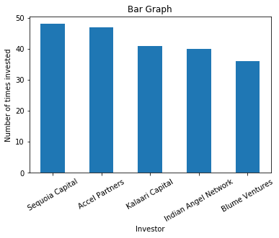Indian Angel Network | 40

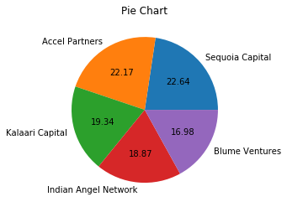Blume Ventures | 36

**Question 4:**

Even after putting so much effort in finding the probable investors, it didn't turn out to be helpful for your friend. So you went to your investor friend to understand the situation better and your investor friend explained to you about the different Investment Types and their features. This new information will be helpful in finding the right investor. Since your friend startup is at an early stage startup, the best-suited investment type would be - Seed Funding and Crowdfunding. Find the top 5 investors who have invested in a different number of startups and their investment type is Crowdfunding or Seed Funding. Correct spelling of investment types are - "Private Equity", "Seed Funding", "Debt Funding", and "Crowd Funding". Keep an eye for any spelling mistake. You can find this by printing unique values from this column. There are many errors in startup names. Ignore correcting all, just handle the important ones - Ola, Flipkart, Oyo and Paytm.

**Explanation:**

According to question, from suggestion of one of my friends I have collected the list of the investors, their invest type, Seed funding or Crowd funding. Drawn a bar graph between investor and the number of investments and pie graph for number of invests.

* So these are the top five investors who invest in new startup or new stage startup.
* In pie graph these are the top five investors who invest in either seeding of crowd funding.
* So if anyone want to start new startup, then these are best top five investors.
* So me and my friend will contact these five investors.

Investor | No_of_time_invest

-------------------------------------------

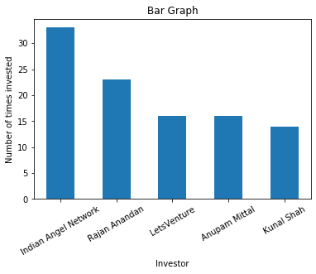Indian Angel Network | 33

Rajan Anandan | 23

LetsVenture | 16

Anupam Mittal | 16

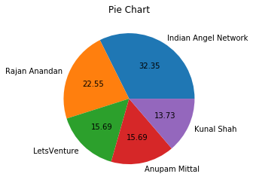Kunal Shah | 14

**Question 5:**

Due to your immense help, your friend startup successfully got seed funding and it is on the operational mode. Now your friend wants to expand his startup and he is looking for new investors for his startup. Now you again come as a saviour to help your friend and want to create a list of probable new new investors. Before moving forward you remember your investor friend advice that finding the investors by analysing the investment type. Since your friend startup is not in early phase it is in growth stage so the best-suited investment type is Private Equity. Find the top 5 investors who have invested in a different number of startups and their investment type is Private Equity. Correct spelling of investment types are - "Private Equity", "Seed Funding", "Debt Funding", and "Crowd Funding". Keep an eye for any spelling mistake. You can find this by printing unique values from this column.There are many errors in startup names. Ignore correcting all, just handle the important ones - Ola, Flipkart, Oyo and Paytm.

**Explanation:**

According to question, from suggestion of one of my friend I have collected the list of the investors, their invest type, ‘Private Equity’. Drawn a bar graph between investor and the number of investments and a pie graph for number of investments

* So these are the top five investors who invest in growth stage startup or established startup.
* In pie graph these are the top five investors who invest as Private Equity.
* So if anyone wants investors for new established startup, then these are best top five investors.
* So me and my friend will contact with these five investors.

Investor | No_of_time_invest

-------------------------------------------

Sequoia Capital | 45

Accel Partners | 43

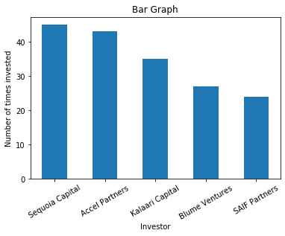Kalaari Capital | 35

Blume Ventures | 27

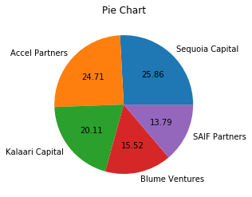SAIF Partners | 24